E-commerce Sales Data Analysis Project
Project Date: 2026-03-07
Author: Data Analysis Project Submission

1. Project Overview
This project analyzes an e-commerce sales dataset to identify product performance, regional sales distribution, and sales trends over time. The goal is to demonstrate a complete data analysis pipeline including data loading, cleaning, analysis, visualization, and reporting.

2. Objectives
- Understand overall sales performance
- Identify top-performing products
- Analyze sales contribution by region
- Observe sales trends over time
- Provide insights for business decision-making

3. Project Structure
project/
│
├── data/
│ └── sales_data.csv
│
├── visualizations/
│ ├── sales_by_product.png
│ ├── sales_by_region.png
│ └── sales_trend.png
│
├── report/
│ └── analysis_report.docx
│
├── main.py
├── requirements.txt
└── README.md

4. Data Analysis Pipeline

4.1 Data Loading
The dataset is loaded using pandas. Validation checks ensure the file exists and columns are properly formatted.

4.2 Data Cleaning
- Handle missing values
- Convert date fields to datetime format
- Validate numeric columns
- Remove duplicates if necessary

4.3 Data Analysis
Key metrics calculated in the analysis include:
- Total Revenue
- Average Order Value
- Units Sold
- Unique Customers
- Product revenue ranking
- Regional sales distribution

5. Visualizations

5.1 Sales by Product
This bar chart shows the total revenue generated by each product category.
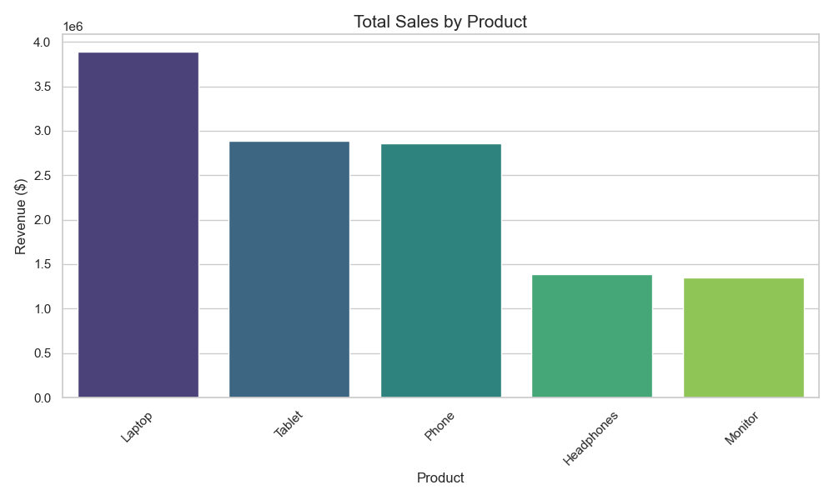
Insight: Laptops generate the highest revenue followed by tablets and phones. This indicates strong demand for high-value electronics.

5.2 Regional Sales Distribution
This pie chart illustrates how sales are distributed across different regions.
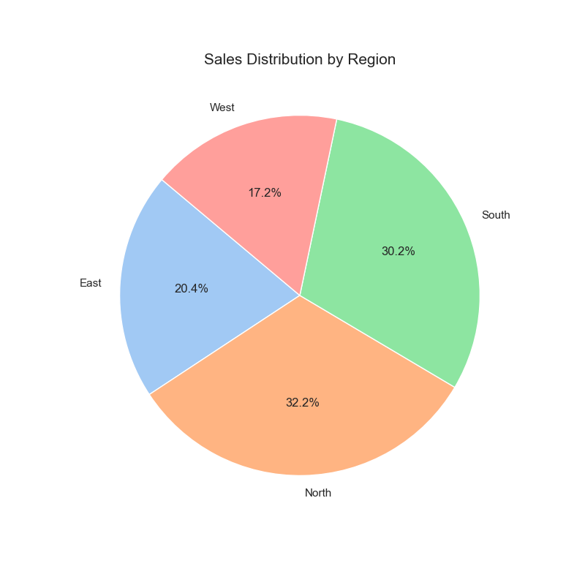
Insight: The North region contributes the largest share of sales, followed closely by the South region.

5.3 Daily Sales Trend
This line chart shows how sales revenue changes over time.
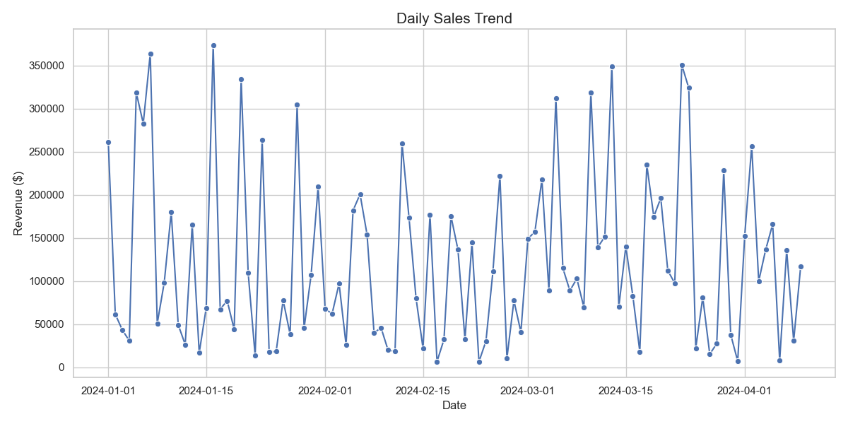
Insight: Daily revenue fluctuates significantly, suggesting possible seasonal effects, marketing campaigns, or demand variations.

6. Key Findings
1. Laptops are the highest revenue generating product.
2. North region contributes the largest percentage of total sales.
3. Sales fluctuate significantly over time.
4. Lower-performing products may need marketing support.

7. Business Recommendations
- Maintain strong inventory for high-performing products like laptops.
- Expand marketing campaigns in regions with lower sales.
- Analyze sales spikes to identify successful promotions.
- Consider bundling low-performing products with high-demand items.

8. Error Handling and Validation
The analysis script includes error handling to ensure reliability:
- Check if dataset exists before loading
- Validate column names
- Handle missing or invalid data values
- Use try/except blocks to prevent crashes

9. Technologies Used
- Python
- Pandas
- Matplotlib
- NumPy
- Jupyter Notebook / Python Script

10. Conclusion
This project demonstrates a full data analysis workflow from raw dataset to business insights. The visualizations help stakeholders quickly understand performance trends and identify growth opportunities.

